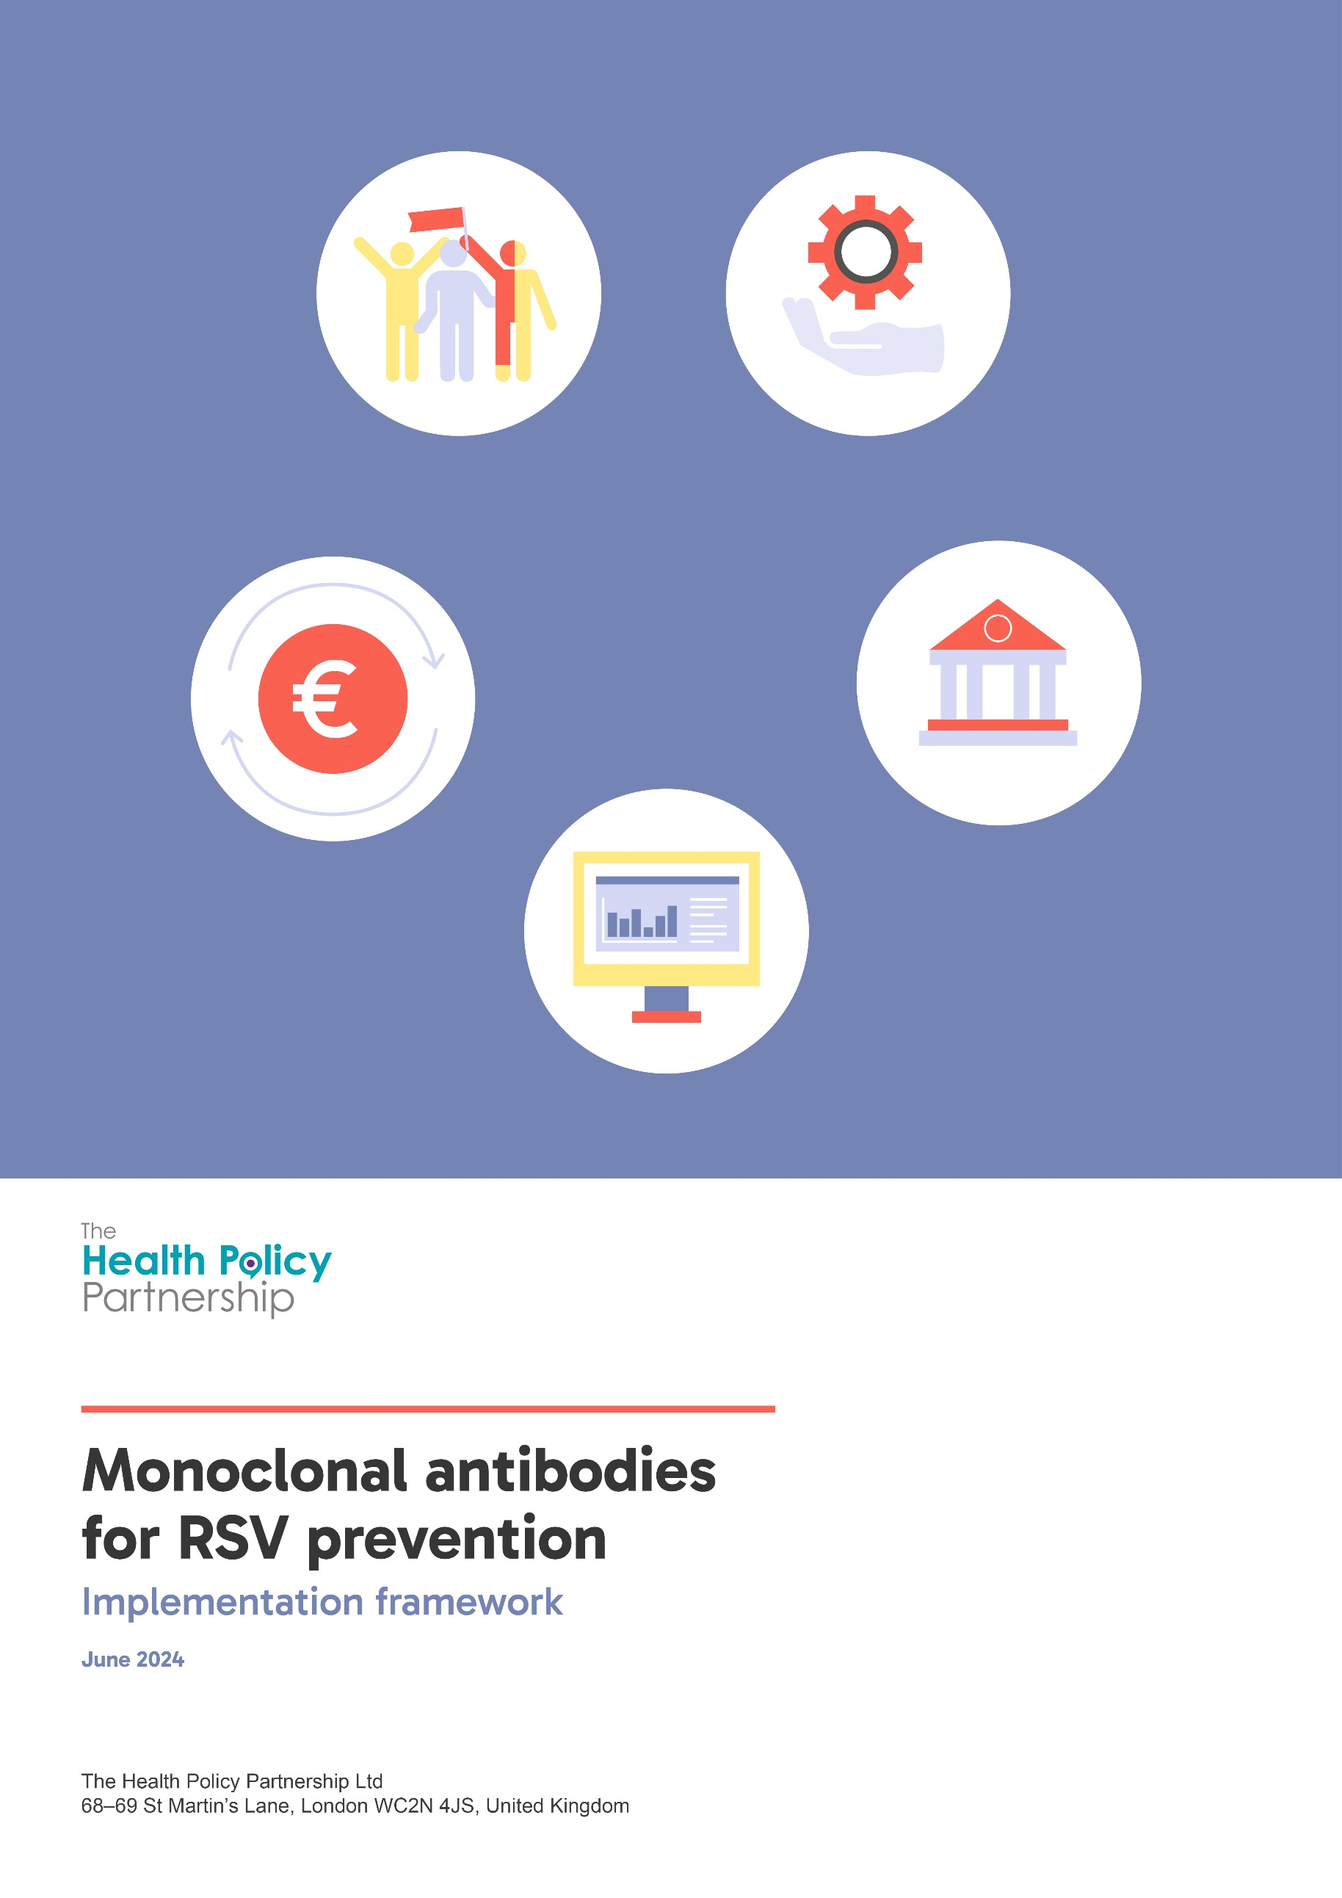
Monoclonal antibodies for RSV prevention
  - Implementation framework
June 2024
This implementation framework was developed by The Health Policy Partnership in close consultation with the project Steering Committee:
- Elena Bozzola, National Councillor, Italian Paediatric Society, Italy
- Michelle Fiscus, Chief Medical Officer, Association of Immunization Managers, US
- Jaime Pérez Martín, Head, Prevention and Health Protection Service, Murcia Health Department, Spain
- Manuel Sanchez-Luna, Head of Neonatology, Gregorio Marañón General University Hospital, Spain
- Catherine Weil-Olivier, Honorary Professor of Paediatrics, Paris Cité University, France
- Martin Wetzke, Paediatrician, Department of Paediatric Pulmonology, Allergology and Neonatology, Hannover Medical School, Germany

This implementation framework was produced by The Health Policy Partnership (HPP) as part of a project that was initiated and funded by Sanofi and AstraZeneca. All outputs are non-promotional and evidence based. HPP retains editorial control on behalf of the project Steering Committee.
Contents
Introduction 4
Respiratory syncytial virus 4
Monoclonal antibodies for RSV prevention 4
Implementation of RSV prevention programmes using mAbs 5
About the RSV mAb implementation framework 7
Framework structure 8
RSV mAb implementation framework 10
1 Governance and leadership 10
1.1 Recommendations and approvals 10
1.2 Leadership and support 11
1.3 Clinical guidelines 11
2 Reimbursement and funding 12
3 Demand 14
3.1 Epidemiology and burden of RSV 14
3.2 Awareness and information 15
4 Service provision 16
4.1 Organisation and logistics 16
4.2 Health system capacity 18
4.3 Workforce capacity 19
5 Monitoring and assessment 20
References 22
Appendix 24

Introduction

Respiratory syncytial virus
Respiratory syncytial virus (RSV) is a common virus that can cause severe illness in young children. Most children are infected with RSV by their second birthday and can experience cold- or flu-like symptoms ranging from mild upper respiratory illness to serious lower respiratory tract infection.¹ RSV frequently causes difficulty breathing, especially in younger babies,¹ and results in thousands of infant deaths each year worldwide.²
RSV places significant pressure on health systems. It is a leading cause of hospitalisation for children in their first year of life, and is the most common cause of bronchiolitis and pneumonia in infants.¹ In 2019, there were an estimated 33 million cases of acute lower respiratory infection associated with RSV globally, and 3.6 million of these required hospital admission.² In regions with temperate climates, including most of Europe and North America and parts of Asia,³ RSV activity peaks during the winter months.¹ Alongside other respiratory infections such as influenza and COVID-19, RSV imposes a substantial burden on healthcare services (inpatient and outpatient settings) each winter.⁴ ⁵

Monoclonal antibodies for RSV prevention
Monoclonal antibodies (mAbs) can protect infants from RSV through passive immunity, which works differently to traditional vaccines. Traditional vaccines induce the body to produce antibodies and other immune system components, protecting it from illness.⁶ However, vaccines for newborns can be problematic due to a poor immune response, and because of safety concerns.⁷ Instead, passive immunisation – whereby a person directly receives antibodies rather than producing their own – is an effective alternative.⁸ Passive immunity among newborns is usually achieved when antibodies produced by the mother’s body cross the placenta before birth and work in the baby’s body to fight infection for the first weeks or months of life.⁸ It is also possible to induce passive immunity by directly administering mAbs against a particular illness, such as RSV.
The purpose of implementing an RSV immunisation programme for all infants using a long-acting mAb is to protect them, and to reduce pressure on health systems. While a mAb against RSV has been available for some time, it has only been administered to infants born prematurely and/or with relevant comorbidities, who are considered to be at very high risk of severe illness from RSV, and requires monthly doses during RSV season.⁹ Recently, however, a longer-acting mAb for RSV prevention has been developed and, in many countries, has received regulatory approval for marketing authorisation and been recommended for use in all infants entering their first RSV season.⁹⁻¹³ Long-acting mAbs that are specific to RSV have been shown to significantly reduce hospitalisations in clinical trials and in real-world settings in countries that have already implemented an all-infants immunisation programme.¹⁴⁻¹⁶ Given the high prevalence and severe impact of RSV, an all-infants immunisation programme using the mAb could significantly reduce the burden of RSV diseases on infants, their families and health systems. Successful implementation of such a programme will require coordination across various domains of the health system.

Implementation of RSV prevention programmes using mAbs
Careful planning is required to ensure health systems are ready to implement RSV prevention programmes using the long-acting mAb in a way that maximises protection of all infants. As mAbs represent an innovative approach to RSV prevention, successful implementation may require adaptations to ensure health systems are ready for widespread delivery.⁵ Some key aspects of the mAb for RSV that will require particular attention and consideration from policymakers and health system planners are outlined in Box 1.

Box 1. Key aspects of the mAb that need to be considered when planning for the implementation of an all-infants immunisation programme using the mAb for RSV
Novelty of prophylactic mAbs: While the mAb serves the same public health objective and is delivered in a way that is similar to a vaccine, immunisation of infants using mAbs is an innovative approach that may not be well suited to existing governance, regulation or reimbursement procedures, which may need to be revised or new procedures put in place. It may also be unfamiliar to healthcare professionals and the lay public, so tailored awareness campaigns and training will be required.
Seasonality of RSV: To ensure timely protection against RSV and maximise the effect of the long-acting mAb, infants born during RSV season should receive the mAb soon after birth, while infants born outside of RSV season should receive the mAb as they are entering their first RSV season.⁹ For infants with certain conditions that place them at increased risk of severe infection, national recommendations vary, but the mAb should generally be given again as they enter their second RSV season.¹⁷ ¹⁸ Delivery of catch-up campaigns for infants born before the RSV season will potentially involve increased workload for healthcare professionals and high demand for doses of the mAb at the start of the campaign. Policymakers will need to consider how best to implement an immunisation programme to meet these needs, and this will likely require coordination and data sharing between hospitals and outpatient settings.
Delivery channels: Infants born during RSV season should ideally receive the mAb as soon as possible after birth to prevent infection. As immunisations are not routinely given to newborns, hospital maternity wards and birth centres may need to develop and implement new procedures to ensure staff are trained and all infants receive the mAb before discharge. Additional considerations will be needed for infants who are born at home. At the same time, infants born before RSV season, along with older infants who are at increased risk of severe infection, will need to be included in a catch-up programme at the beginning of the season, and health system planners will need to determine the best approach to achieve high coverage.
Requirement for careful demand planning: Evidence-based estimates of demand for the long-acting mAb must be made well in advance of each RSV season to ensure sufficient doses are available in time for the start of the immunisation campaign. There are two different doses of the long-acting mAb, based on infant weight: infants weighing <5kg require a 50mg dose while those weighing ≥5kg require a 100mg dose.¹⁹ Health system planners will need to ensure an adequate amount of each dose is available in healthcare settings – particularly where catch-up campaigns are delivered.
Need for programme monitoring and assessment: Continued planning and delivery of this innovative approach to prevention will require robust, population-wide data collection and monitoring. To monitor the uptake and effectiveness of the mAb immunisation programme, RSV surveillance and data on immunisation status should be collected and shared between hospitals and the community to support coordination between different settings. Ideally, all these data will be collected and analysed at national level to best inform health system policies for subsequent RSV seasons. As RSV in infancy may be associated with longer-term complications such as wheezing and asthma,²⁰ follow-up programmes are recommended to assess the potential long-term impacts and benefits of RSV prevention.

About the RSV mAb implementation framework
This implementation framework has been developed in consultation with an international, multidisciplinary steering committee. The structure of the framework is derived from a generic health system readiness framework developed by The Health Policy Partnership, based on a review of existing health system readiness frameworks and assessment of health system readiness in other areas of healthcare, and validated by an expert steering committee.²¹ The framework’s domains align with the World Health Organization’s health system building blocks framework.²² Its content is informed by the available published literature, interviews with experts, and analysis of how mAb programmes for RSV were implemented in France, Spain and the US during the 2023/2024 RSV season. It can be used by policy- and decision-makers, researchers, clinicians and patient advocates to encourage evidence-based planning for the implementation of RSV prevention programmes in their local context.
The framework is designed to be adapted to local contexts. It has been framed as a future-oriented tool for countries that are getting ready to implement a mAb immunisation programme for RSV, but the content is applicable to countries at all stages of implementation. Users in countries that have implemented a mAb immunisation programme already can use the framework to identify any residual gaps that should be addressed for future RSV seasons. Similarly, it primarily assumes a national perspective, but can be adapted for use in countries with decentralised health systems, either to plan for implementation in a single region, territory or state, or to plan for national implementation by considering each region, territory or state in turn. We acknowledge that additional adaptations to terminology and local systems may be warranted, and we warmly encourage users to make these changes so that the framework is as useful as possible.
The impact of maternal RSV immunisation on mAb implementation should be considered when using this framework. Additional innovative approaches to RSV prevention in infants – such as an immunisation that can be delivered to pregnant people during the later stage of their pregnancy (known as maternal RSV immunisation) – may become available in some countries and will influence the implementation of the mAb. Providers will need clear guidance and the ability to share and access adequate healthcare data to prevent potential overlap and administration errors.²³ The availability of two options could also make it difficult for health system planners to estimate demand for either option during the first few RSV seasons when they are available. While this framework is designed to support implementation of the long-acting mAb for RSV, the impact of maternal RSV immunisation must be considered where it is available, and some questions have been included to address this.

Framework structure
The framework has been developed to evaluate readiness for mAb implementation in different domains of the health system. It can be used to conduct a detailed analysis of how immunisation programmes using the RSV mAb will be implemented and to identify gaps across five domains of a health system:²² governance and leadership, reimbursement and funding, demand, service provision, and monitoring and assessment (Figure 1).
Figure 1. Definitions of framework domains
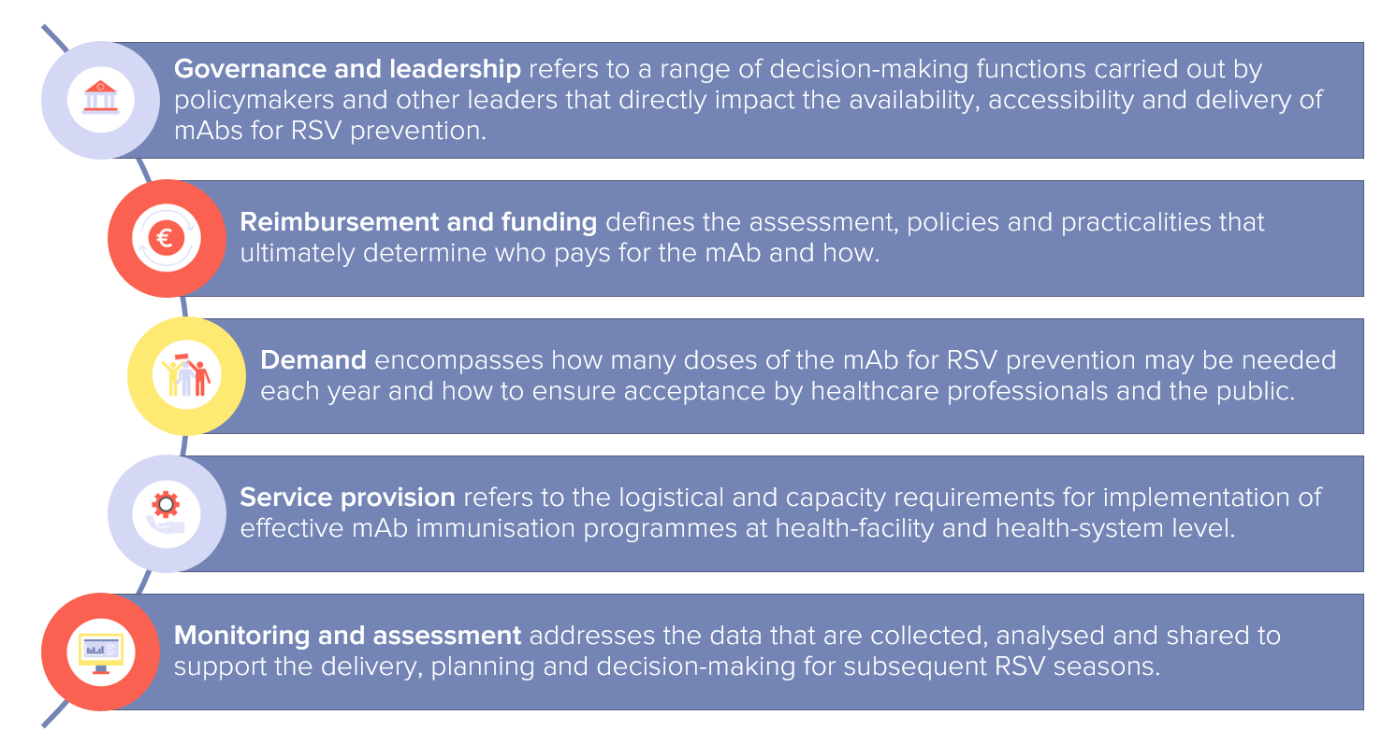

Each domain of the framework includes different components to support comprehensive research and identification of particular gaps or challenges to be addressed (Figure 2):
- Most domains include subdomains, distinct categories to help organise and focus the research.
- Indicators are questions that assess a key component of a domain or subdomain.
- Assessment questions help break down and address the indicator question.
Figure 2. Framework components
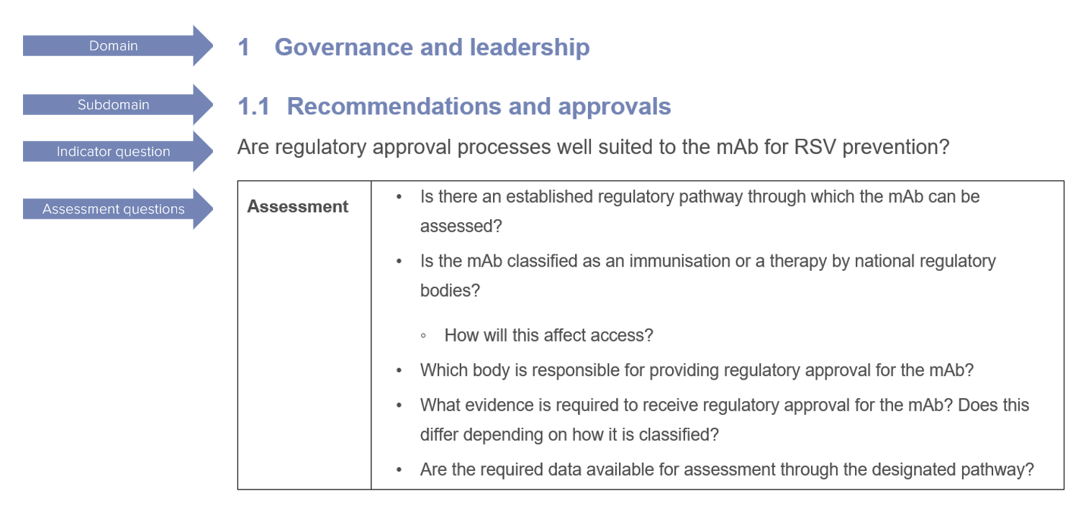

RSV mAb implementation framework

Governance and leadership

Recommendations and approvals
Are regulatory approval processes well suited to the mAb for RSV prevention?
Assessment | Is there an established regulatory pathway through which the mAb can be assessed?  Is the mAb classified as an immunisation or a therapy by national regulatory bodies?  How will this affect access?  Which body is responsible for providing regulatory approval for the mAb?  What evidence is required to receive regulatory approval for the mAb? Does this differ depending on how it is classified?  Are the required data available for assessment through the designated pathway?

What is the appropriate process for reviewing and making recommendations for the use of mAbs for RSV in all infants?
Assessment | Will the mAb be evaluated by a National Immunisation Technology Assessment Group (NITAG)?  If it will not be evaluated by a NITAG:  Will it be evaluated by another established national body with clear assessment procedures?  How will assessment by a different government body affect implementation (e.g. in terms of funding and access)  Is there a legal barrier to NITAG evaluation?  Will the mAb be included in a national immunisation programme?  What factors could facilitate the inclusion of the mAb in a national immunisation programme?  To what extent does the inclusion in a national immunisation programme influence funding, delivery and coverage?

Leadership and support
Is there national and/or regional leadership and political support for implementation of an all-infants immunisation programme with the RSV mAb?
Assessment | Are government bodies (e.g. ministry of health, regional health departments) in favour of funding and delivering the mAb for all infants?  If not, what are the reasons and how can their concerns be addressed?  Do relevant public health and health service delivery bodies agree on the need to implement an all-infants immunisation programme with the RSV mAb?  If not, what are the reasons for disagreement and how could it affect approval and implementation of the mAb?  Are all relevant disciplines – including clinical professional societies, public health bodies and health service delivery bodies – collaborating to call for the implementation of an all-infants immunisation programme with the RSV mAb?  What strategies do they use?  If some of these groups are not supportive of the mAb, how might this affect implementation and are there any strategies that could encourage acceptance?  Are patient organisations and professional societies actively involved in advocating for an all-infants RSV immunisation programme?  What strategies do they use?  Which national or regional bodies influence immunisation policy and service delivery, and in what ways?

Clinical guidelines
Have clinical guidelines been developed for the delivery of the mAb in all settings?
Assessment | Have clinical guidelines been developed to specify:  which ages are recommended to receive the mAb, and how the recommendations differ for high-risk groups? (e.g. annual doses until age two for infants with conditions that put them at greater risk of severe illness from RSV)  when and where infants should receive the mAb at birth and when and where they should receive it as a catch-up? (i.e. to align with the RSV season)  the correct dose that should be given, based on the infant’s weight?  any contraindications for use of the mAb, including exposure to the maternal immunisation?  recommendations on possible co-administration with other vaccines?  Which national bodies or professional societies are responsible for developing and updating immunisation guidelines?  How will clinical guidelines impact or support implementation?  Has an RSV immunisation target rate been officially defined, communicated and monitored?

Reimbursement and funding
Have the necessary analyses been conducted to inform reimbursement decisions?
Assessment | Has a health technology assessment or other relevant assessment of cost-effectiveness been conducted?  If yes, what was the outcome?  If not, which data and processes are needed to complete such an assessment?

Will reimbursement/payment policies support delivery of the mAb according to national or regional recommendations?
Assessment | How will reimbursement/payment decisions for the mAb be made?  Will the mAb be assessed and funded as a treatment or a vaccine?  Who is responsible for the mAb programme budget planning and when?  Will the necessary funding come from hospital budgets, public health budgets or others?  What is the process for reimbursing/paying for the mAb in hospital settings?  What is the process for reimbursing/paying for the mAb in primary care?  Will healthcare providers and hospitals be reimbursed/paid for delivering the mAb to all eligible infants?  Will the mAb be delivered without requiring an out-of-pocket payment (even if this will later be reimbursed)?  Would upfront payment or copayment be a barrier to access?  Will health insurers (public and/or private) cover any costs of the mAb that are not reimbursed/paid by a national health system or government-funded immunisation programme?  Would out-of-pocket costs be a barrier to access for some families or populations?

Will providers be adequately incentivised to offer and deliver the mAb?
Assessment | How will delivery of the mAb at birth be billed and/or paid?  Will the cost of the mAb be bundled with all other costs charged for birth and neonatal care, potentially adding a cost to the delivery of maternity care for hospitals?  Will payers provide sufficient reimbursement to incentivise hospitals and/or individual clinicians to offer and deliver the mAb?  Where healthcare providers purchase the mAb independently, will adequate and timely reimbursement be guaranteed to encourage participation in the programme?  Are there performance-based financial incentives to reach RSV immunisation targets?

Demand

Epidemiology and burden of RSV
What is the typical burden of RSV infection in infants under 12 months of age?
Assessment | How many cases of RSV are there in infants each year?  How many hospitalisations and outpatient appointments are attributed to RSV infection in infants and young children each year?  How does RSV infection contribute to seasonal pressures on health systems?  What is the estimated economic cost of RSV infection among infants?  Are there any groups that are disproportionately affected by RSV infection?  What is the impact and burden of the longer-term health and social consequences of RSV infection?

How many infants are expected to receive the mAb each year?
Assessment | - How many babies are born each year in each region/area?  - What proportion of infants will weigh ≥5.0kg when they are eligible to receive the mAb?*  - How are the start and end of the RSV immunisation campaign defined and communicated?  - What proportion of parents are expected to accept the mAb for their infant?  - Are there any populations that are less likely to access or accept the mAb?  - How will demand for the mAb be estimated, and which national or regional body is responsible for making this estimate? How far in advance is demand estimated?  - How will demand for the mAb be affected by the introduction of maternal immunisation?  - What is the ordering process and timeline at national, regional and/or hospital/pharmacy level?
*Infants weighing <5.0kg require a 50mg dose and infants weighing ≥5.0kg require a 100mg dose, so quantities of each dose will need to be ordered.

Awareness and information
Is appropriate information about RSV and the mAb readily available for expectant parents and parents of young children?
Assessment | What factual, up-to-date information about RSV and the mAb – produced by trusted government organisations, professional societies or patient organisations – is available and accessible for parents?  When and how often is information about the mAb shared through public education campaigns?  What communication channels may be most effective in reaching parents of infants?  Which healthcare professionals will be actively involved in educating parents about RSV and the mAb both before and after birth?  Does the information refer to RSV infection in an understandable way (e.g. by using the most familiar terms related to RSV)?  Does the information describe RSV mAbs in the most effective way (e.g. by referring to them as an immunisation or preventive treatment, according to local attitudes and preferences)?  What information is available in the relevant languages and in a culturally sensitive way to meet the needs of local populations to ensure equity in access?  What data are available about public awareness of RSV and/or mAbs, and about public attitudes towards these topics? How can this information be used to help design awareness campaigns?  What are the existing public information or education strategies that can be leveraged to raise awareness and understanding of RSV and the mAb?  Who is involved in delivering these strategies?

Are all relevant healthcare professionals trained and educated on the importance of RSV prevention and accepting of the mAb?
Assessment | Please refer to Table 1A in the Appendix for relevant healthcare professionals.  What evidence is available to indicate that relevant healthcare professionals understand what the mAb is and that they are aware of the available safety and efficacy data?  What is the evidence (e.g. from surveys or letters of support from professional societies) that relevant healthcare professionals agree that RSV prevention, and the implementation of an immunisation programme using the mAb, should be prioritised?  How will all relevant healthcare professionals receive role-specific training or education on RSV prevention, immunisation delivery and public education strategies?  Which scientific or professional societies are involved, or should be involved, in raising awareness of the mAb among healthcare professionals and in providing relevant training?  What may be the best communication channels for reaching the relevant healthcare professionals?

Service provision

Organisation and logistics
Are plans in place to ensure the mAb immunisation programme will be organised and delivered to all eligible infants?
Assessment | How will the mAb programme be implemented consistently and equitably across the country?  What plans are in place to specify:  at what point, and in what setting, babies born during RSV season will be offered and receive the mAb?  at what point, and in what setting, babies born outside of RSV season will be offered and receive the mAb (e.g. existing routine visits)?  how parents of eligible infants will be identified and invited to receive the mAb at the start of RSV season?  what strategies will be put in place to make the mAb accessible for underserved populations and to support uptake?  How do plans allow for greater demand and an increase in workload for healthcare professionals at the beginning of RSV season, when the catch-up campaign for babies born out of season is delivered?  Which person or group is responsible for developing these plans and coordinating their implementation?  Which existing processes or pathways can be utilised to support the delivery of the mAb in hospitals?  Which existing health check appointments, processes or pathways can be utilised to support the delivery of the mAb in primary care or community settings?

How will the mAb be transported and delivered to the healthcare facilities that require it?
Assessment | What is the planned logistical procedure for ensuring the mAb doses are transported from the supplier to each healthcare facility in a timely manner for the RSV season?  Which body will be responsible for managing the order and transport of the mAb and ensuring each healthcare facility receives the required number of doses?  How will healthcare facilities communicate with the responsible body about supply of, and demand for, the mAb?

How will maternal immunisation affect the implementation of an infant mAb immunisation programme?
Assessment | Complete this section if maternal immunisation against RSV is available or planned to be rolled out in this country.  Is the mAb or maternal immunisation preferred or prioritised in national recommendations and guidelines?  What proportion of pregnant people receive/are expected to receive the RSV vaccine?  What is the guidance for administering the mAb in infants whose mothers were immunized?  How are healthcare professionals informed on how and when to use the mAb or maternal immunisation to prevent potential overlap and administration errors?

Health system capacity
Are healthcare facilities equipped to store and administer the mAb?
Assessment | Do all healthcare facilities implementing the mAb immunisation programme have the necessary equipment and systems in place? This includes:  procedures for prescribing and documenting the administration of the mAb  equipment needed for giving injections, including sharps disposal containers, biohazard bins and personal protective equipment  equipment needed for the proper storage of the mAb and staff who are trained in the cold chain requirements (which are the same as for other vaccines).  Will all doses be delivered at the beginning of RSV season, or will they be stored centrally and allocated to healthcare facilities on a rolling basis throughout RSV season?  What are the plans for collecting and returning unused or expired doses at the end of the campaign?

Are adequate data-sharing systems in place to support implementation of the mAb immunisation programme across different sites?
Assessment | Is there an electronic data-sharing system in place that can be accessed by hospitals and primary care centres to identify infants who have received the mAb and (if relevant) whose mothers received the maternal RSV vaccine?  If not, is there any systematic way for providers across the healthcare system to identify which infants have received the mAb (or passive immunisation through maternal RSV immunisation)?  Can existing data-sharing systems be used to collect data about access and uptake of the mAb?  Are data systems or electronic health records used to:  trigger reminders for healthcare professionals to offer the mAb, or for parents to request it?  identify and recall high-risk infants to receive the mAb in their second and subsequent RSV seasons (as directed by national guidelines)?  Is data sharing a priority for the health system more broadly?

Workforce capacity
Do hospitals and primary care centres have sufficient workforce capacity to deliver the mAb to all infants during RSV season?
Assessment | Please refer to Table 1A in the Appendix for a list of relevant healthcare professionals who should be considered.  What are the existing workforce-related challenges in delivering neonatal or postnatal services that suggest the implementation of a new immunisation programme could be difficult?  Which healthcare professionals are allowed to administer intramuscular injections in infants?  Is there a known shortage of primary care staff that could affect the feasibility of delivering the mAb to newborns during RSV season or as a catch-up programme in the autumn?  What are the attitudes and beliefs of healthcare staff about implementing a new immunisation programme for all infants?  Which healthcare professionals are authorised to prescribe the mAb? Which healthcare professionals are authorised to administer it?  Within the wider health system, are there calls to expand the right to prescribe and administer injections to a greater range or number of healthcare professionals, which may be relevant to the mAb?

Monitoring and assessment
Is there sufficient data collection on RSV to guide future planning and implementation of the mAb immunisation programme?
Assessment | Is mandatory routine surveillance in place to monitor the incidence, burden and seasonality of RSV?  Is virological surveillance in place in both hospitals and outpatient settings to differentiate cases of RSV from influenza and COVID-19, and to monitor the activity of different RSV strains?  Is point-of-care testing used in hospitals and outpatient settings to support RSV surveillance?  Apart from clinical research data, how will the following real-world data on the mAb routinely be collected and reported?  Data on safety and effectiveness.  Data on coverage and uptake, including data on which population groups are more or less likely to access or accept the mAb.  Data on healthcare professionals’ and parents’ attitudes and experiences with the mAb.  Data on cost-effectiveness, including the cost-effectiveness of different approaches to implementation.  How and when will surveillance and uptake data be updated and publicly shared during RSV season?  Can data collection for RSV infection and the mAb be incorporated into existing data collection and surveillance systems, or will new systems be developed?  Who is accountable for developing, implementing and running data collection platforms?

How will data on RSV and the mAb be used to inform health system planning?
Assessment | Will data on mAb uptake be used to inform demand estimates in subsequent RSV seasons?  Will evidence of the effectiveness of the mAb in preventing hospitalisations be used to advocate for sustained political will to provide and promote the mAb?  Will all collected data on RSV and mAb uptake and impact be made available to health system planners rapidly, or in real time, to enable evidence-based decision-making?  Will there be longer-term follow-up to assess the wider health impacts of preventing RSV in infancy?

Appendix
Table 1A. Healthcare professionals who may be involved in the implementation of mAbs for RSV at different contact points
Contact point | Healthcare professionals | Potential role(s) in mAb implementation
Antenatal care | Midwife  Gynaecologist/ obstetrician | Include RSV prevention and the mAb in antenatal preparation and education discussions.
Birth/neonatal care | Midwife  Nurse  Neonatologist  Paediatrician | Educate parents about the mAb and offer it as part of routine neonatal care.  Prescribe and administer the mAb.
Routine checks in the first weeks of life | Community nurse/midwife  Primary care nurse  Primary care doctor  Paediatrician | Identify which infants have (not) received the mAb.  Educate parents about the mAb and offer it during routine checks.  Prescribe and administer the mAb.
Dedicated appointments at the start of RSV season | Community nurse  Primary care nurse  Primary care doctor  Paediatrician | Educate parents about the mAb and offer it to babies entering their first RSV season.  Prescribe and administer the mAb.

References

1. Piedimonte G, Perez MK. 2014. Respiratory syncytial virus infection and bronchiolitis. Pediatrics in review 35(12): 519-30
2. Li Y, Wang X, Blau DM, et al. 2022. Global, regional, and national disease burden estimates of acute lower respiratory infections due to respiratory syncytial virus in children younger than 5 years in 2019: a systematic analysis. The Lancet 399(10340): 2047-64
3. Met Office. Climate zones. Available from: https://www.metoffice.gov.uk/weather/climate/climate-explained/climate-zones [Accessed 05/03/24]
4. World Health Organization. 2023. COVID-19, influenza, and other respiratory viruses - 2023-2024 autumn and winter season. [Updated 29/09/23]. Available from: https://www.who.int/europe/news-room/questions-and-answers/item/covid-19--influenza--and-other-respiratory-viruses---2023-2024-autumn-and-winter-season [Accessed 05/03/24]
5. European Health Management Association. 2022. The health system burden of respiratory syncytial virus (RSV) in Europe. Dublin: EHMA
6. World Health Organization. How do vaccines work? [Updated 08/12/20]. Available from: https://www.who.int/news-room/feature-stories/detail/how-do-vaccines-work [Accessed 05/03/24]
7. Saso A, Kampmann B. 2017. Vaccine responses in newborns. Seminars in immunopathology 39(6): 627-42
8. Centers for Disease Control and Prevention. Immunity Types. [Updated 24/09/21]. Available from: https://www.cdc.gov/vaccines/vac-gen/immunity-types.htm [Accessed 05/03/24]
9. Jones JM, Fleming-Dutra KE, Prill MM, et al. 2023. Use of Nirsevimab for the Prevention of Respiratory Syncytial Virus Disease Among Infants and Young Children: Recommendations of the Advisory Committee on Immunization Practices - United States, 2023. MMWR Morbidity and mortality weekly report 72(34): 920-25
10. European Medicines Agency. Beyfortus: nirsevimab. [Updated 15/01/24]. Available from: https://www.ema.europa.eu/en/medicines/human/EPAR/beyfortus#ema-inpage-item-product-details [Accessed 05/03/24]
11. Department of Health and Social Care. 2023. Respiratory syncytial virus (RSV) immunisation programme for infants and older adults: JCVI full statement, 11 September 2023. London: DHSC
12. Food and Drug Administration. 2023. FDA approves new drug to prevent RSV in babies and toddlers. [Updated 17/07/23]. Available from: https://www.fda.gov/news-events/press-announcements/fda-approves-new-drug-prevent-rsv-babies-and-toddlers [Accessed 14/03/24]
13. Grupo de Trabajo utilizacion de nirsevimab frente a infeccion por virus respiratorio sincitial de la Ponencia de Programa y Registro de Vacunaciones, Comision de Salud Publica del Consejo Interterritorial del Sistema Nacional de Salud. 2023. Recomendaciones de utilización de nirsevimab frente a virus respiratorio sincitial para la temporada 2023-2024. Madrid: Ministerio de Sanidad
14. Drysdale SB, Cathie K, Flamein F, et al. 2023. Nirsevimab for Prevention of Hospitalizations Due to RSV in Infants. The New England journal of medicine 389(26): 2425-35
15. Ares-Gómez S, Mallah N, Santiago-Pérez M-I, et al. Effectiveness and impact of universal prophylaxis with nirsevimab in infants against hospitalisation for respiratory syncytial virus in Galicia, Spain: initial results of a population-based longitudinal study. The Lancet Infectious Diseases: 10.1016/S1473-3099(24)00215-9:
16. López-Lacort M, Muñoz-Quiles C, Mira-Iglesias A, et al. 2024. Early estimates of nirsevimab immunoprophylaxis effectiveness against hospital admission for respiratory syncytial virus lower respiratory tract infections in infants, Spain, October 2023 to January 2024. Euro Surveill: 10.2807/1560-7917.Es.2024.29.6.2400046:
17. Consejo Interterritorial. 2024. Recomendaciones de utilizacion de nirsevimab para la temporada 2024-2025 en Espana. Madrid: Ministerio de Sanidad
18. Centers for Disease Control and Prevention. Healthcare providers: RSV prevention information. [Updated 28/09/23]. Available from: https://www.cdc.gov/vaccines/vpd/rsv/hcp/child.html [Accessed 06/03/24]
19. American Academy of Pediatrics. 2023. Nirsevimab (Beyfortus) Product & Ordering Information. [Updated 11/10/23]. Available from: https://www.aap.org/en/patient-care/respiratory-syncytial-virus-rsv-prevention/nirsevimab-beyfortus-product--ordering-information/ [Accessed 16/04/24]
20. Zhou Y, Tong L, Li M, et al. 2021. Recurrent Wheezing and Asthma After Respiratory Syncytial Virus Bronchiolitis. Frontiers in pediatrics 9: 649003
21. The Health Policy Partnership. 2022. Readiness assessment framework. London: The Health Policy Partnership
22. World Health Organization. National Health Planning Tools - Health System Building Blocks. Available from: https://extranet.who.int/nhptool/BuildingBlock.aspx [Accessed 12/03/24]
23. Centers for Disease Control and Prevention. CDC Clinician Outreach and Communication Activity: Information on Respiratory Syncytial Virus (RSV) Vaccine Administration Errors in Young Children and Pregnant People. [Updated 22/01/24]. Available from: https://emergency.cdc.gov/newsletters/coca/2024/012224.html [Accessed 02/05/24]

Please cite this document as: Morris T, Tate J, Shackleton E. 2024. Monoclonal antibodies for RSV prevention: implementation framework. London: The Health Policy Partnership

© 2024 The Health Policy Partnership. The authors do not permit modification of pages
1–9 of this document. The RSV mAb implementation framework is licensed under the Creative Commons Attribution-ShareAlike 4.0 International (CC BY-SA 4.0) Licence. To view a copy of this licence, visit https://creativecommons.org/licenses/by-sa/4.0/.

