Radioligand Therapy Readiness Assessment Framework

June 2021

This framework was developed by The Health Policy Partnership with guidance from a multi-stakeholder International Advisory Group. The group has had full editorial control over all international-level outputs, with national-level groups maintaining editorial control for national outputs. The project is supported with funding by Advanced Accelerator Applications, a Novartis Company, with additional support from Nordic Nanovector.

**Acknowledgements**

**With many thanks to our International Advisory Group members:**

The following organisations endorse this framework:

Contents

Introduction 4

Radioligand therapy 4

Health system readiness for radioligand therapy 5

About the Radioligand Therapy Readiness Assessment Framework 6

Structure of the framework 6

Applying the framework 8

Radioligand Therapy Readiness Assessment Framework 9

1 Governance 9

1.1 Leadership and planning 9

1.2 Guidelines and best practice 10

2 Regulation and reimbursement 11

2.1 Regulation 11

2.2 Reimbursement and funding 12

3 Identified need 13

3.1 Epidemiology 13

3.2 Patient awareness and information 13

3.3 Healthcare professional awareness and referral patterns 13

4 Service provision 14

4.1 Workforce capacity 14

4.2 Health facility capacity 15

5 Health information 17

5.1 Research and data 17

References 18

Appendix 19

Introduction

Radioligand therapy

**Radioligand therapy is a highly targeted cancer therapy which uses systemic radiation.** Targeted radioisotope therapies are well established as a treatment option for thyroid cancer1 2 and bone metastases due to prostate cancer,3 among other clinical indications. Radioligand therapy has evolved from this targeted approach of organ-level precision to cellular-level precision. It is currently licensed for use for certain types of neuroendocrine neoplasms (NENs) and lymphoma. It is also under evaluation for metastatic castration-resistant prostate cancer (mCRPC) and other cancers. The mechanism by which radioligand therapy works is not specific to any particular tumour type; the therapy could be applied to many other cancers where a suitable receptor is identified (*Box 1*). These possible applications are currently being investigated in clinical trials.

|  |
| --- |
| Box 1. What are radioligands?  A radioligand is made of two parts: a ligand, which can find cancer cells that have a particular surface molecule, and a radioisotope, which emits therapeutic radiation to kill these cells. The ligand can target radiation to cells anywhere in the body. Sometimes the ligand is an antibody, in which case the approach is known as radioimmunotherapy.  **The Radioligand Therapy Readiness Assessment Framework uses the term radioligand therapy**, but there are various terms used for the approach, including peptide-receptor radionuclide therapy (PRRT), systemic radiation therapy, targeted radionuclide therapy, targeted radiotherapy and molecular radiotherapy. |

Health system readiness for radioligand therapy

|  |
| --- |
| Box 2. What do we mean by integration and readiness in the context of radioligand therapy?  **Integration** is the adoption and assimilation of radioligand therapy into every aspect of a health system (i.e. governance, regulation, reimbursement and service delivery frameworks) in order to ensure its availability to all people who may benefit from it.  **Readiness** is the ability of a health system to rapidly and sustainably adapt policies, processes and infrastructure to support integration of a new radioligand therapy. |

Making radioligand therapy available in clinical practice has policy implications beyond healthcare. Radioligand therapy is a relatively new approach to cancer treatment. It has traditionally received little attention outside nuclear medicine, but there is growing interest in establishing the approach as a core component of cancer care. For this to happen, policy implications must be considered within healthcare and beyond. An approach looking at all relevant pillars of the health system is needed to effectively plan for a full integration of radioligand therapy into cancer care. Policy areas that need to be considered when developing a comprehensive policy response to this goal have been identified in the report [*Radioligand therapy: realising the potential of targeted cancer care*](http://www.radioligandtherapy.com/app/uploads/2020/01/Radioligand_therapy_realising_the_potential_of_targeted_cancer_care.pdf).4

We have sought to define what is needed across the health system and within policy frameworks to support the integration of radioligand therapy into cancer care, now and in the future. We have translated this knowledge into a readiness assessment framework, which can be used to evaluate current system-level integration of radioligand therapy to clarify what is needed to successfully implement radioligand therapy into cancer care (*Box 2*).

We hope this framework can be used by researchers, clinicians and patient advocates to encourage evidence-based planning for radioligand therapy within their national context. We also hope it can contribute to a shared vision across the cancer community of what health system readiness should entail as we look to the future of cancer care and the introduction of new treatment approaches more generally.

About the Radioligand Therapy Readiness Assessment Framework

Structure of the framework

The framework has been developed to evaluate the current situation in different critical areas, or domains, of a health system. It enables taking a close look at the integration of radioligand therapy into five domains of a health system: governance, regulation and reimbursement, identified need, service provision, and health information (*Figure 1* and *2*).

Figure 1. A systems approach to readiness for radioligand therapy

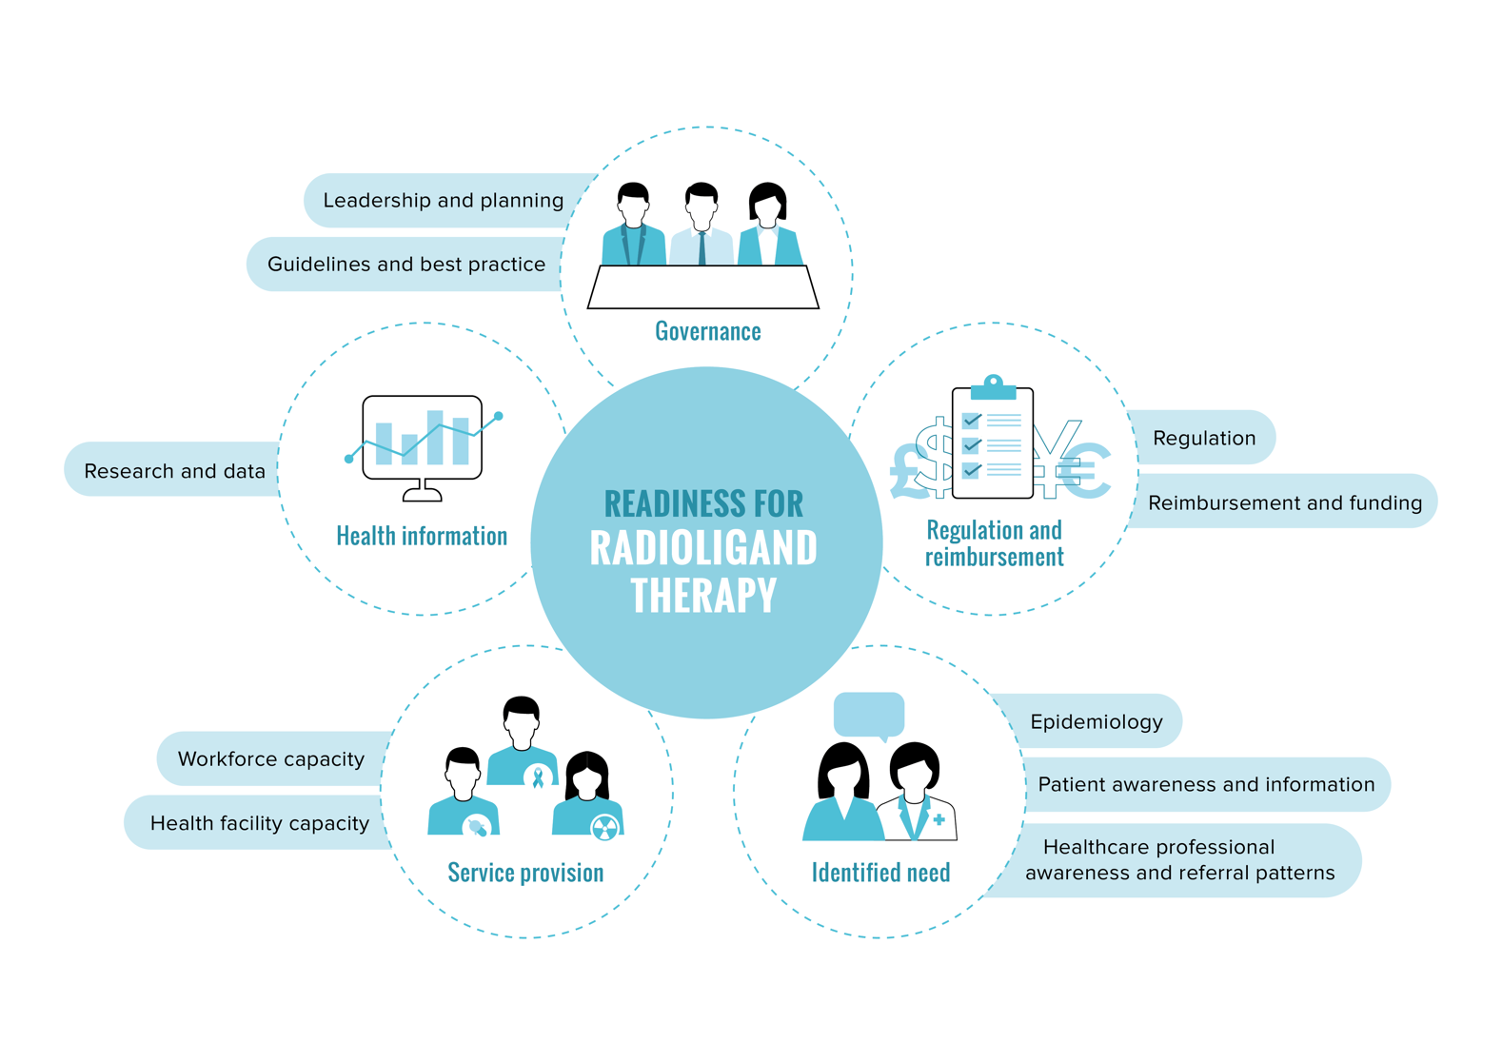

Figure 2. Definitions of domains used in the framework

Each domain of the framework is organised into several components, allowing for the collection of both quantitative and qualitative data (*Figure 3*):

* **subdomain** – a distinct category within a domain, to help focus the research
* **indicator** – a specific question to assess an important component of a subdomain
* **metric** – a precise question to help break down and measure each indicator; these are largely designed to stimulate quantitative data collection
* **contextual factor** – a broad question that aims to add greater depth to the analysis; these will mostly require qualitative data to answer.

Figure 3. Framework components



Applying the framework

**We piloted the framework in two countries and used findings from the pilots to ground the framework in data.** We piloted the framework in the UK and the US, which led to the development of national policy-focused situation analyses to inform healthcare system planning within each country. This exercise allowed us to refine the framework and we hope to apply it to other countries in the future.

We warmly encourage interested parties to adapt and apply this framework to their own contexts. We have developed a complementary [user guide](https://www.radioligandtherapy.com/app/uploads/Framework-User-guide.pdf), which outlines a standardised approach to applying the framework. It describes how to validate findings and use them to identify areas for policy action. It also includes a glossary of the main technical terms used in the framework.

To learn more about how to use the framework in your country and to receive a suite of other supporting materials we have created, please visit [www.radioligandtherapy.com](https://www.radioligandtherapy.com/).

Radioligand Therapy Readiness Assessment Framework

Complete the framework based on national-level research. Terminology may need to be adapted to each country as appropriate.

# Governance

## Leadership and planning

### Is there a national/regional cancer strategy or plan that includes, or could include, radioligand therapy?

|  |  |
| --- | --- |
| Metrics | Which are the most relevant cancer strategies or plans and how are they organised?  How are therapeutic approaches considered? Is radioligand therapy included? |
| Contextual factors | What is the reach and perceived influence of these strategies or plans?  Are there mechanisms in place to ensure these strategies or plans are implemented? |

### Are there national/regional disease-specific strategies or plans that include, or could include, radioligand therapy?

|  |  |
| --- | --- |
| Metrics | Assess separately for each clinical indication where radioligand therapy is licensed for use or is in late-stage clinical trials.  Is there a national/regional disease-specific management strategy or plan?  How are therapeutic approaches considered? Is radioligand therapy included? |
| Contextual factors | How important are these strategies or plans in clinical practice?  Are there mechanisms in place to ensure these strategies or plans are implemented? |

### Is there national leadership and political support for radioligand therapy?

|  |  |
| --- | --- |
| Metrics | Are patient organisations, professional societies and political groups actively involved in raising awareness and understanding of radioligand therapy?  Does radioligand therapy feature in policy discussions around cancer care? |
| Contextual factors | Which stakeholders are involved in influencing policy change?  Are policy and decision-makers aware of radioligand therapy? |

## Guidelines and best practice

### Do disease-specific guidelines include radioligand therapy?

|  |  |
| --- | --- |
| Metrics | Assess separately for each clinical indication where radioligand therapy is licensed for use or is in late-stage clinical trials.   * Do disease-specific guidelines include radioligand therapy? In what circumstances is it recommended? |
| Contextual factors | If more than one guideline exists for a specific clinical indication, how do they differ? Who uses which guideline and under what circumstances? |

### Is there national guidance for the delivery of radioligand therapy across clinical indications?

|  |  |
| --- | --- |
| Metrics | Does national guidance exist for the delivery of radioligand therapy in general?  Does it provide guidance on:  the roles and responsibilities of healthcare professionals involved in delivery?  the built environment and equipment needed for delivery?  preparation and administration of treatment?  radiation protection and disposal of radioactive waste?  Are there local frameworks and/or protocols to support the implementation of national guidance for radioligand therapy in the local context? |
| Contextual factors | If more than one piece of guidance exists, how do they differ?  Is the guidance actively used in clinical practice? By which clinicians? |

# Regulation and reimbursement

## Regulation

### Are regulatory approval processes well adapted to radioligand therapy?

|  |  |
| --- | --- |
| Metrics | How is radioligand therapy classified by national regulatory agencies?  Has radioligand therapy been licensed for use in the country? For which clinical indications?  How does the regulatory approval process work for diagnostics and associated radioligand therapies? Are these processes linked? |
| Contextual factors | Which body is responsible for providing regulatory approval for radioligand therapy? Is this provided at a national level, regional level, or both? |

### Are regulations for the production and supply of radioisotopes appropriate for radioligand therapy?

|  |  |
| --- | --- |
| Metrics | How are imaging and therapeutic radioisotopes for radioligand therapy obtained?  Are there mechanisms to ensure consistent supply of radioisotopes? |
| Contextual factors | Are there any capacity issues, current or foreseen, in the supply of radioisotopes for radioligand therapy?  Would the production, procurement or regulation of radioisotopes need to be adapted if use of radioligand therapies increased? |

### Are regulations for the administration of radioisotopes appropriate for radioligand therapy?

|  |  |
| --- | --- |
| Metrics | What are the regulations for individuals working with medical radioisotopes?  What are the regulations for institutions providing radioligand therapy? |
| Contextual factors | How do regulatory issues in the licensing of medical professionals and employers/institutions impact access to radioligand therapy?  Is the current number of healthcare professionals licensed to deliver radioligand therapy sufficient to meet potential increased demand? |

### Are regulations for the management of medical radioactive waste applicable to radioligand therapy?

|  |  |
| --- | --- |
| Metrics | What are the regulations for the management of medical radioactive waste? |
| Contextual factors | Are differences in radioisotopes, such as half-lives, purity and radiation quality, considered?  Are healthcare facilities able to manage current and future radioactive waste resulting from radioligand therapy? |

## Reimbursement and funding

### How are existing reimbursement and funding mechanisms applied to radioligand therapy?

|  |  |
| --- | --- |
| Metrics | Assess separately for each clinical indication where radioligand therapy is licensed for use at the country level.  Has radioligand therapy been granted reimbursement or undergone a health technology assessment that has led to it being funded by the health system?  If yes, how and by whom?  If yes, what are the conditions for reimbursement/funding?  How is radioligand therapy funded (e.g. sickness funds/public healthcare, medicines fund, private insurance, other)? |
| Contextual factors | Are existing reimbursement/health technology assessment evidence requirements considered applicable to, or appropriate for, radioligand therapy?  If applicable, what issues exist in reimbursement mechanisms between types of providers (e.g. public, private, other)? How do these affect access to licensed radioligand therapy?  Would the level of reimbursement change if radioligand therapy were used in new and larger patient populations?  Is funding provided for imaging agents used to assess a person’s eligibility for radioligand therapy? |

# Identified need

## Epidemiology

### What is the current burden of disease?

|  |  |
| --- | --- |
| Metrics | Assess separately for each clinical indication where radioligand therapy is licensed for use or is in late-stage clinical trials.  What is the prevalence and incidence at the national level?  How many people may be eligible for radioligand therapy? |
| Contextual factors | How are incidence and prevalence expected to change in the next 5–10 years? |

## Patient awareness and information

### Is there information for patients on radioligand therapy as a treatment option?

|  |  |
| --- | --- |
| Metrics | Assess separately for each clinical indication where radioligand therapy is licensed for use or is in late-stage clinical trials.  Is information available on radioligand therapy as a treatment option? |
| Contextual factors | Does information on radioligand therapy clearly address eligibility criteria, delivery procedure, and potential benefits and side effects?  How and by whom is information disseminated? |

## Healthcare professional awareness and referral patterns

Please consider *Table A1* in the Appendix while answering the metrics in this section.

### Are relevant healthcare professionals aware of radioligand therapy as a treatment option?

|  |  |
| --- | --- |
| Metrics | Assess separately for each clinical indication where radioligand therapy is licensed for use or is in late-stage clinical trials.  Is radioligand therapy included in the training for the role? If yes, to what extent is it covered? |
| Contextual factors | Are patients generally referred for radioligand therapy if they are suspected to be eligible?  How do existing radioligand therapies impact healthcare professionals’ perceptions of the approach? |

# Service provision

## Workforce capacity

Please consider *Table A2* in the Appendix while answering the metrics in this section.

### Which healthcare professionals are involved in providing radioligand therapy?

|  |  |
| --- | --- |
| Metrics | Assess separately for each clinical indication where radioligand therapy is licensed for use or is in late-stage clinical trials.  Which professionals are involved in providing radioligand therapy and what are their roles and responsibilities?  At what point(s) in the pathway are they involved? |
| Contextual factors | Who can prescribe radioligand therapy?  What barriers and facilitators exist in terms of ensuring optimal referral and delivery of radioligand therapy?  Do healthcare professionals referring patients and administrating radioligand therapy generally reside at the same institution? How does this impact provision? |

### Is there sufficient capacity to meet current demand for radioligand therapy?

|  |  |
| --- | --- |
| Metrics | Assess separately for each healthcare professional involved in providing radioligand therapy.  How many healthcare professionals in each role are there in the country? |
| Contextual factors | Will healthcare professional be able to keep pace with the potential increased demand for radioligand therapy? |

### How are nuclear medicine specialists involved in multidisciplinary decision-making around treatment?

|  |  |
| --- | --- |
| Metrics | Assess separately for each clinical indication where radioligand therapy is licensed for use or is in late-stage clinical trials.  What are the roles and responsibilities of nuclear medicine professionals in the multidisciplinary tumour board? |
| Contextual factors | How will involvement of the nuclear medicine professional in the multidisciplinary tumour board change if the use of radioligand therapy increases?  What are the key barriers and facilitators for collaboration between nuclear medicine professionals and the multidisciplinary tumour board? |

## Health facility capacity

### Are staging and eligibility assessments for radioligand therapy appropriate to meet current and future demand?

|  |  |
| --- | --- |
| Metrics | Assess separately for each clinical indication where radioligand therapy is licensed for use or is in late-stage clinical trials.  What are the criteria for assessing eligibility for radioligand therapy and how are they established?  How many sites in the country have imaging capacity for radioligand therapy?  Is there an adequate number of trained professionals to perform imaging and interpret scans for radioligand therapy? |
| Contextual factors | What barriers and facilitators exist in achieving optimal imaging capacity for radioligand therapy?  How will imaging capacity need to change if use of radioligand therapy increases? |

### How are radioligand therapy services organised?

|  |  |
| --- | --- |
| Metrics | Assess separately for each clinical indication where radioligand therapy is licensed for use or is in late-stage clinical trials.  How many sites provide radioligand therapy at the national level?  Are there criteria for becoming a site that delivers radioligand therapy?  How are radioligand therapy services organised? |
| Contextual factors | In which department(s) is radioligand therapy typically delivered?  How are radioligand therapy services distributed across the country?  What are the barriers and facilitators to the delivery of radioligand therapy at the hospital level? |

### Is the built environment appropriate for the delivery of radioligand therapy?

|  |  |
| --- | --- |
| Metrics | Is radioligand therapy generally delivered as an inpatient or outpatient procedure?  Do sites delivering radioligand therapy have:  a dedicated lead-lined room and bathroom for patients?  appropriate storage space for radioactive waste? |
| Contextual factors | Are there additional differences in the delivery of radioligand therapy depending on the radioisotope that is used?  How will the built environment need to be adapted if use of radioligand therapy increases? |

# Health information

## Research and data

### Is there sufficient data collection on radioligand therapy to guide future planning and practice?

|  |  |
| --- | --- |
| Metrics | Apart from the need for ongoing clinical trial data, are the following data collected in relation to radioligand therapy?  Registry and audit data  Real-world data on effectiveness in clinical practice  Patient-reported outcomes data  Economic data |
| Contextual factors | To what extent are data used to support national workforce and system-level planning?  To what extent is it feasible to integrate data collection on the use of new treatments into existing, indication-specific data collection mechanisms?  What data are needed to support informed decision-making on radioligand therapy in the future? |

References

1. McCready VR. 2017. Radioiodine – the success story of Nuclear Medicine. *Eur J Nuclear Med Mol Imaging* 44(2): 179-82

2. Filetti S, Durante C, Hartl D*, et al.* 2019. Thyroid cancer: ESMO Clinical Practice Guidelines for diagnosis, treatment and follow-up. *Ann Oncol*: 10.1093/annonc/mdz400

3. Poeppel TD, Handkiewicz-Junak D, Andreeff M*, et al.* 2018. EANM guideline for radionuclide therapy with radium-223 of metastatic castration-resistant prostate cancer. *Eur J Nuclear Med Mol Imaging* 45(5): 824-45

4. The Health Policy Partnership. 2020. *Radioligand therapy: realising the potential of targeted cancer care.* London: The Health Policy Partnership

Appendix

Please consider the tables below while answering the metrics in the section on healthcare professional awareness and referral patterns (*Table A1*) and workforce capacity (*Table A2*).

Table A1. Healthcare professionals involved in referrals for radioligand therapy

|  |  |
| --- | --- |
| Clinical indication | Relevant referring healthcare professionals* |
| Neuroendocrine neoplasms | Endocrinologists, gastroenterologists, clinical/medical/radiation oncologists |
| Lymphoma | Haematologists, haemato-oncologists, clinical/medical/radiation oncologists |
| Prostate cancer | Urologists, uro-oncologists, clinical/medical/radiation oncologists |

*May differ between countries.

Table A2. Ideal constitution of treatment teams

|  |  |
| --- | --- |
| Team | Examples of healthcare disciplines involved |
| Radioligand therapy team | Nuclear medicine, radiation oncology, specialist nursing, radiopharmacy, medical physics, administrative support |
| Multidisciplinary team | Clinical/medical/radiation oncology, specialist nursing, nuclear medicine, radiology, pathology, surgery |

About The Health Policy Partnership

[The Health Policy Partnership](https://www.healthpolicypartnership.com/) (HPP) is an independent research organisation, working with partners across the health spectrum to drive the policy and system changes that will improve people’s health.

Please cite as: The Health Policy Partnership. 2021. *Radioligand therapy readiness assessment framework*. London: The Health Policy Partnership.

**Contact information**

The Health Policy Partnership Ltd  
68–69 St Martin’s Lane, London WC2N 4JS, United Kingdom

For more information, please see [www.radioligandtherapy.com](http://www.radioligandtherapy.com) or contact Christine Merkel, Programme Lead for health system readiness at The Health Policy Partnership: christine.merkel@hpolicy.com

© 2021 The Health Policy Partnership. The authors do not permit modification of pages   
1–8 of this document. The Radioligand Therapy Readiness Assessment Framework is licensed under the Creative Commons Attribution-ShareAlike 4.0 International (CC BY-SA 4.0) Licence. To view a copy of this licence, visit <https://creativecommons.org/licenses/by-sa/4.0/>